Session 1
Tasks:
1. Download and install Power BI Desktop on your computer, then open the application and take a screenshot of the blank report interface.
Ans:
Download Power BI from Microsoft Store
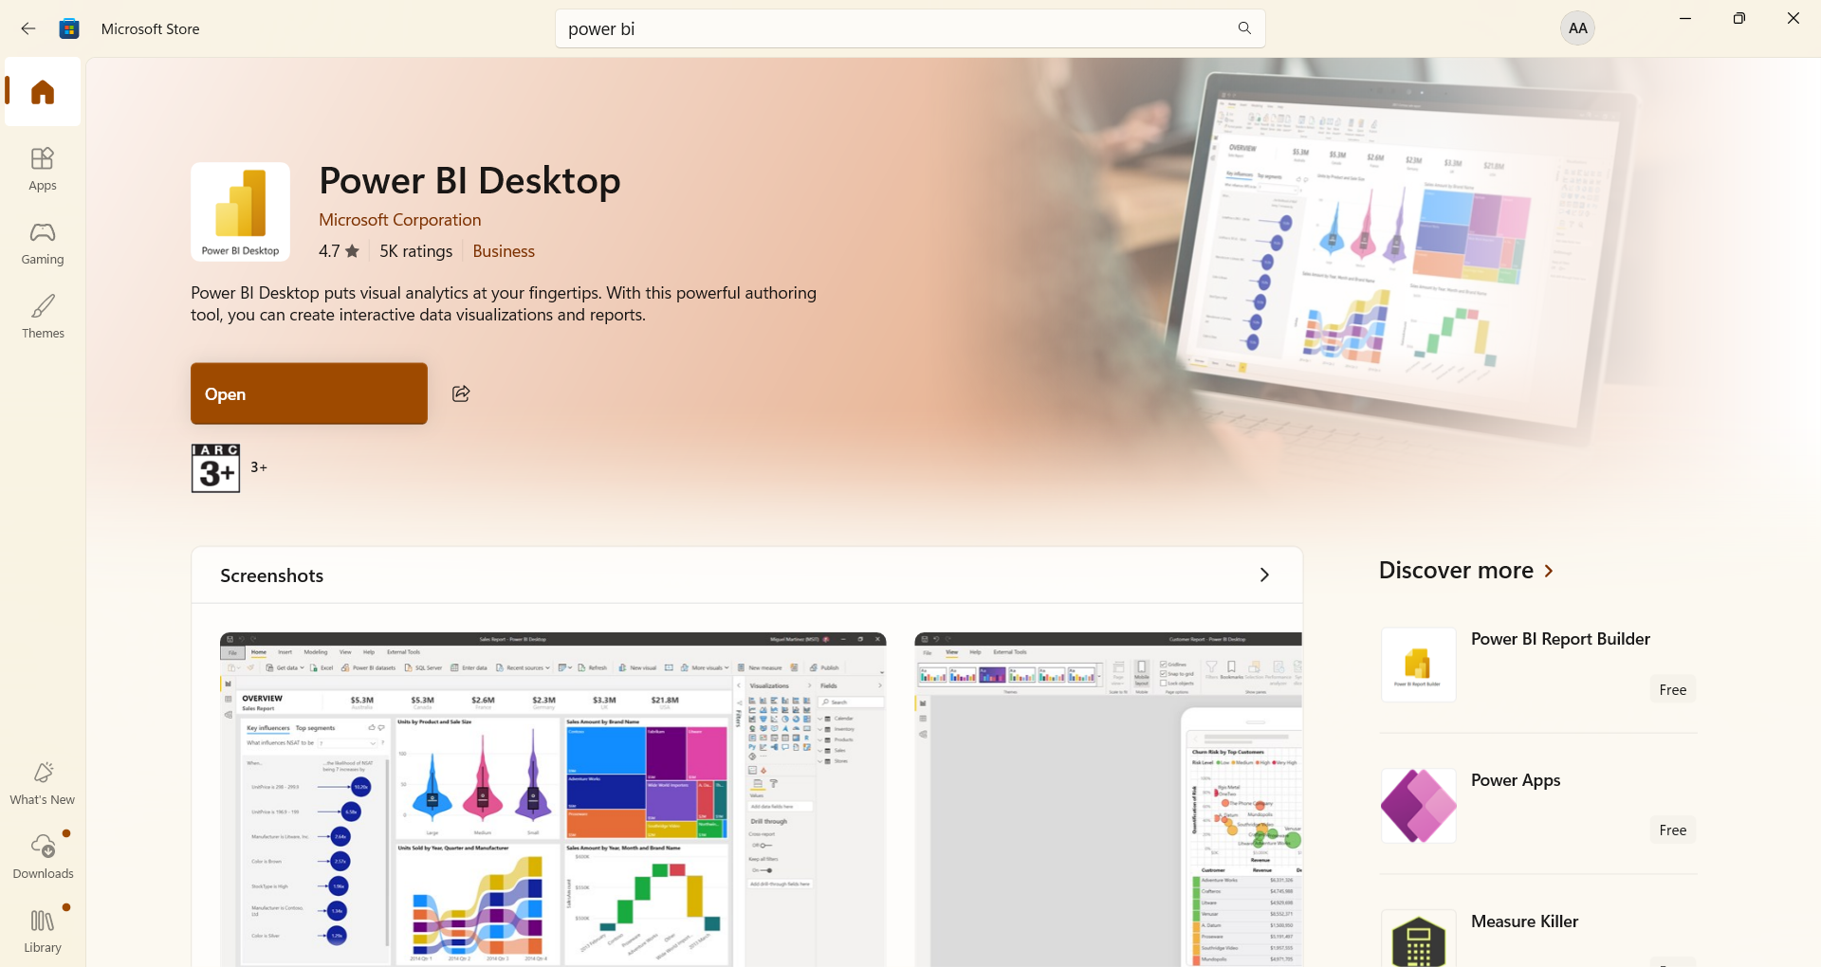
Blank Report Interface:
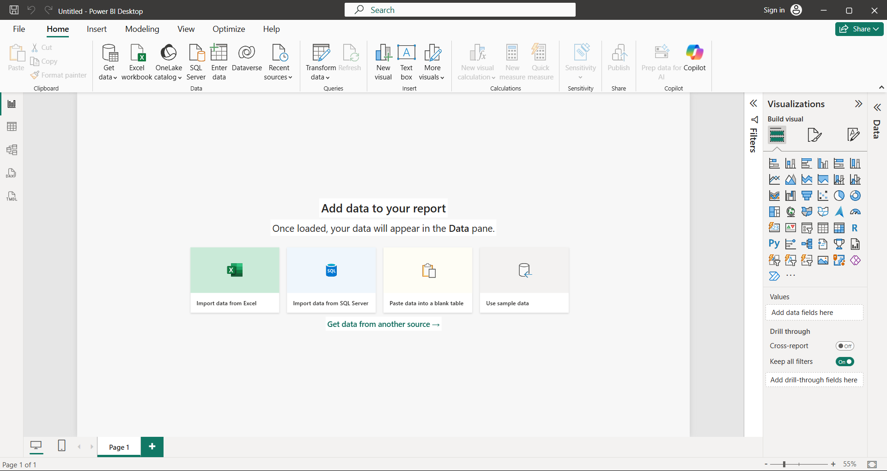

2. Explore the Power BI Desktop interface and identify the following components: Report View, Data View, Model View, Fields Pane, Visualizations Pane, and Filters Pane. Write a short description (1-2 lines) for each component.
Ans:
1. Report View
Point: Main workspace where reports and dashboards are created.
Explanation:
- Here you design charts, graphs, and visuals.
- It is used to present insights in a clear way.
Meaning: This is where final output (report) is built and shown.

2. Data View
Point: Shows data in table format inside Power BI.
Explanation:
- You can see rows and columns of your dataset.
- Helps to understand and verify the data.
Meaning: It is used to look at raw data clearly.

3. Model View
Point: Displays relationships between different tables.
Explanation:
- Shows how tables are connected with each other.
- Useful for managing joins and data structure.
Meaning: It helps in organizing and connecting data properly.

4. Fields Pane (Data Pane)
Point: Contains all tables, columns, and measures.
Explanation:
- You select fields from here to use in visuals.
- It shows the structure of your dataset.
- In latest Power BI, this is called Data Pane (same as Fields Pane).
Meaning: It is like a list of all available data items.

5. Visualizations Pane
Point: Provides different chart options and customization tools.
Explanation:
- You can choose chart types like bar, pie, line, etc.
- Also used to format and design visuals.
Meaning: It is used to create and style charts.

6. Filters Pane
Point: Used to apply filters on data.
Explanation:
- Helps to show only selected data in visuals.
- Can filter based on values, categories, etc.
Meaning: It controls what data is visible in the report.

3. Create a new blank report in Power BI Desktop and add a table visual using the Visualizations Pane. Rename the report page to 'My First Dashboard'.
Ans:
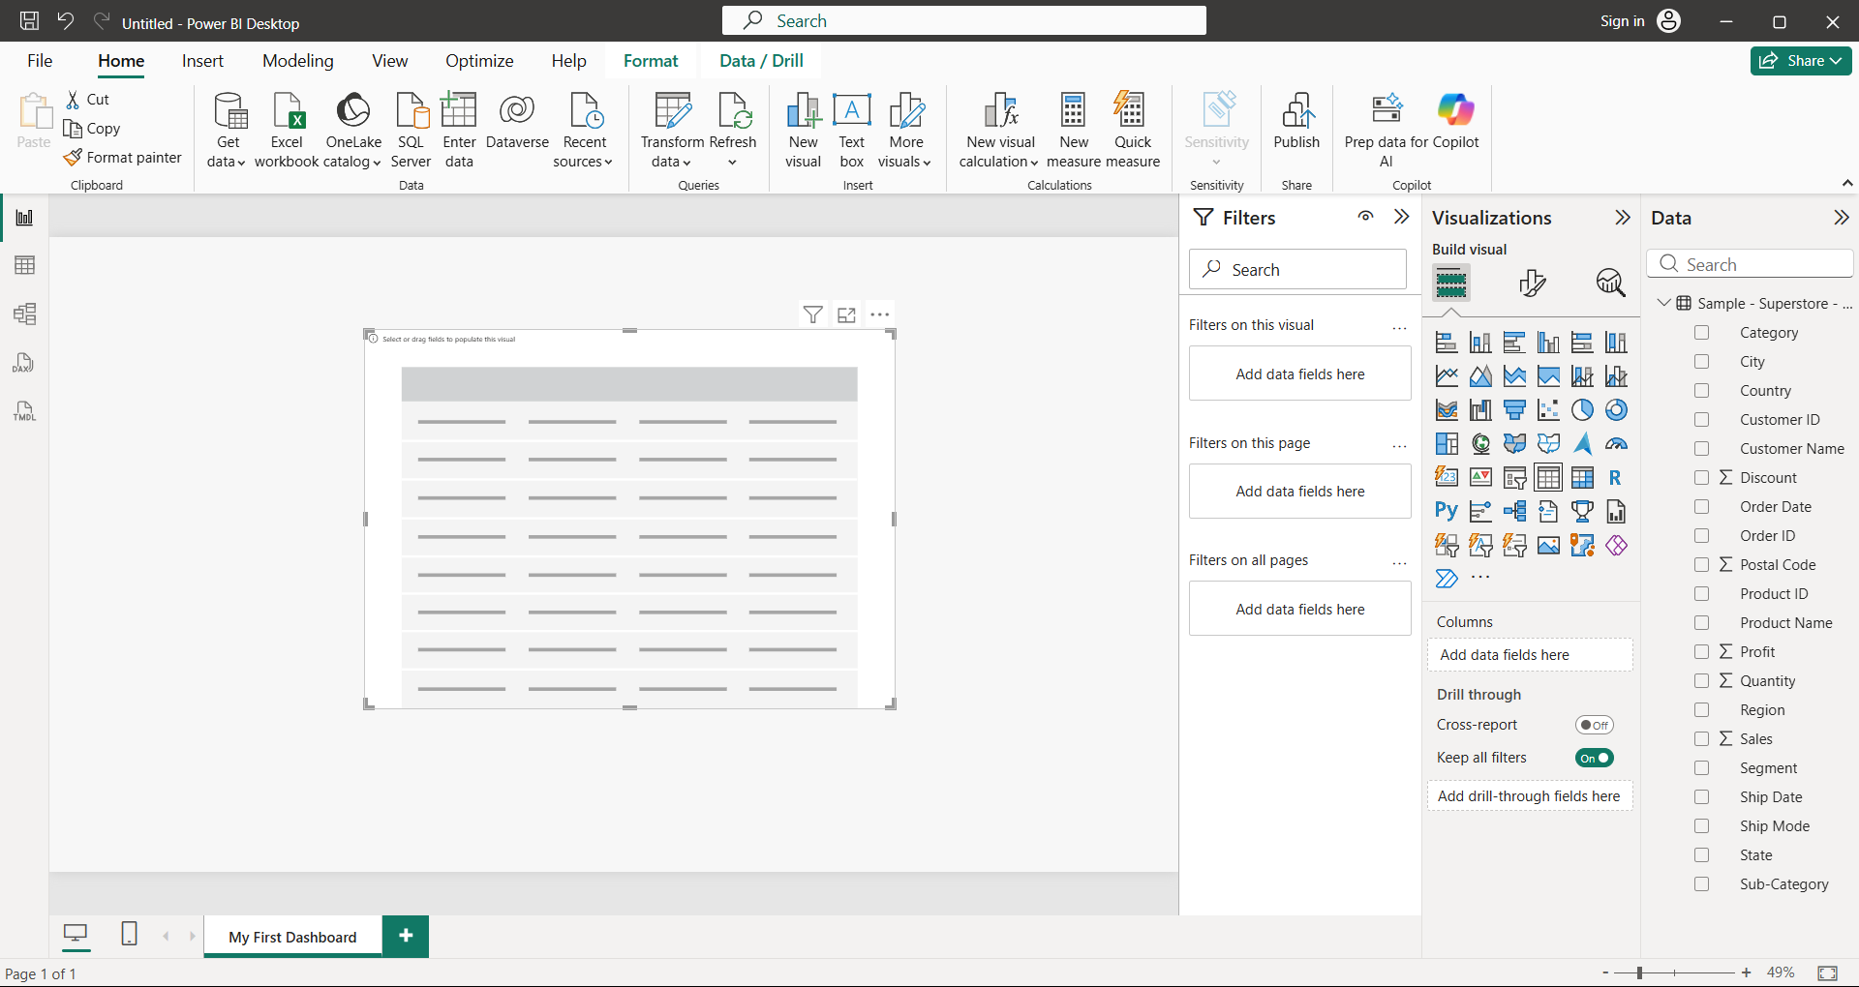

4. List 3 key differences between Excel Dashboards and Power BI Dashboards, focusing on features or workflows you noticed while exploring Power BI Desktop.
Ans:
1. Data Handling & Performance
Point: Power BI can handle large data much better than Excel.
Explanation:
- In Power BI, even big datasets load smoothly without much lag.
- In Excel, when data becomes very large, file becomes slow and difficult to manage.
Meaning: Power BI is more suitable for heavy and real-world data analysis.

2. Interactivity & Visual Experience
Point: Power BI dashboards are more interactive compared to Excel.
Explanation:
- In Power BI, we can click on charts, apply filters, and see instant changes.
- In Excel, dashboards are mostly static and require manual changes like slicers or formulas.
Meaning: Power BI gives a more dynamic and user-friendly experience.

3. Workflow & Automation
Point: Power BI has a more organized and automated workflow.
Explanation:
- In Power BI, data loading, cleaning, modeling, and visualization happen in one place.
- In Excel, we have to do many steps manually like formulas, cleaning, and updates.
Meaning: Power BI makes the overall process faster and more efficient.

